Results, AI assignment 4

1: Easy

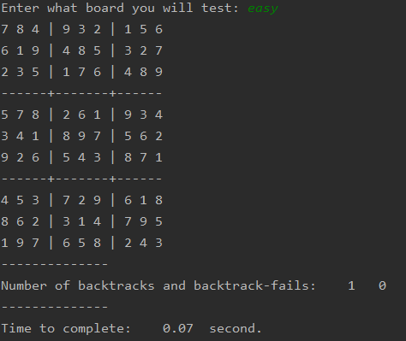

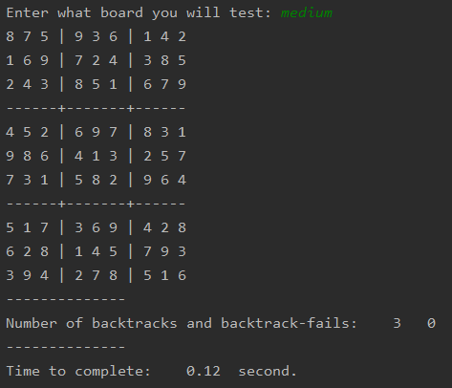2: Medium

3: Hard

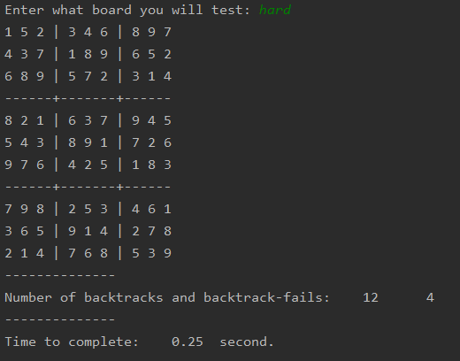

4: Very hard

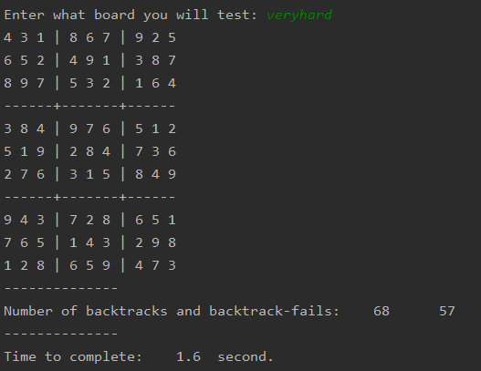

**Comments on numbers**: My understanding

* For the easiest board, the solution was easily available and could be entirely solved using inference in the first state. Inference is called with all arcs in backtracking_search(). All we had to do was to call backtracking once after that, as the solution is validated in this function.
* For the harder boards, we sometimes will assign values that will lead in a dead end, discovered by our inference.
  + The reason why we always get more calls of backtracking than we get fails, is probably because a fail is not discovered before we have assigned several values already.